A corporate technician states, "This bearing *(assembly?)* was sent to *(a)* repair station for inspection and possible repair. The *(repair station's)* inspector observed severe spalling on one of the bearing balls." *(Ball bearing P/N: SA7968. Alright—I confess! Were it not for this incredibly trick photograph I probably would have selected a different submission—Ed.)*

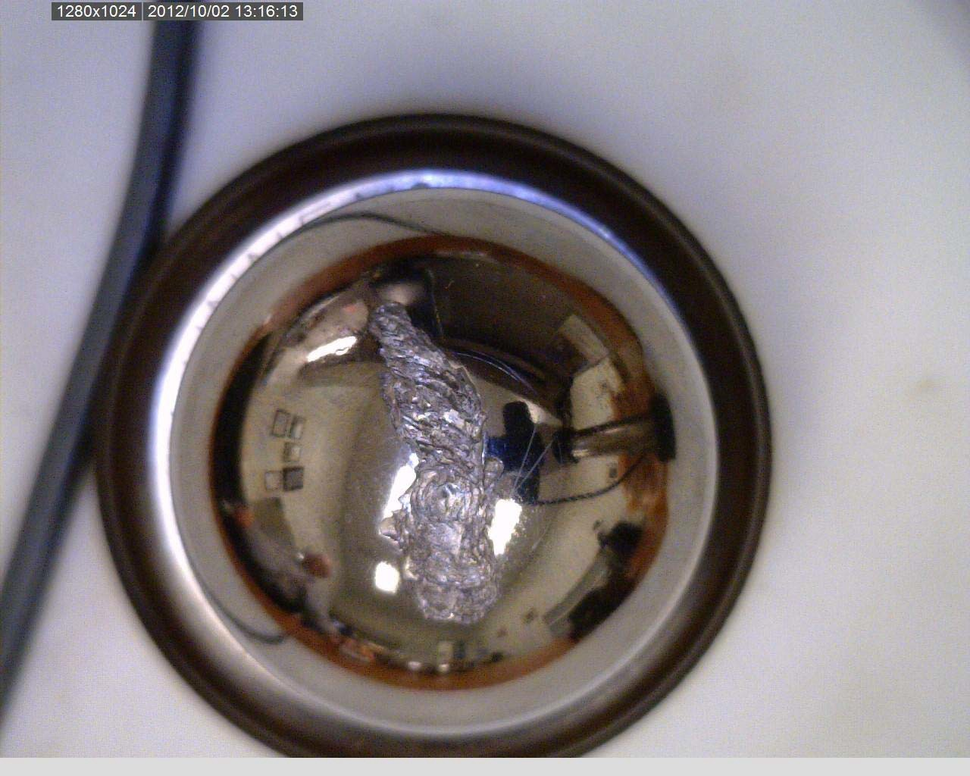

Part Total Time: (Unknown)